CASIA-WebFace, MS-Celeb-1M, AT&T faces dataset,
One-shot learning can be implemented using a Siamese network. As the name indicates, its nothing but, two identical neural networks with exact same weights, but taking two distinct inputs.

This loss will be small when the inputs to the networks are similar and large when inputs differ from each other.

One shot learning process – one image to learn and detect
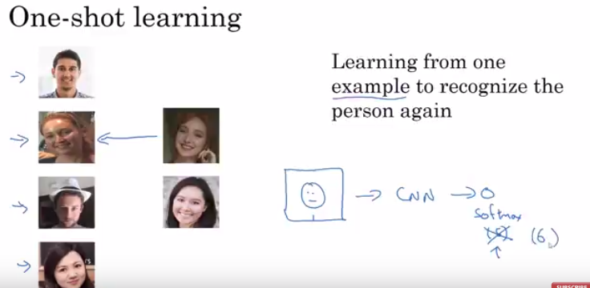
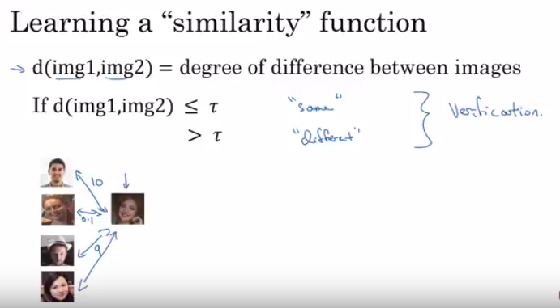

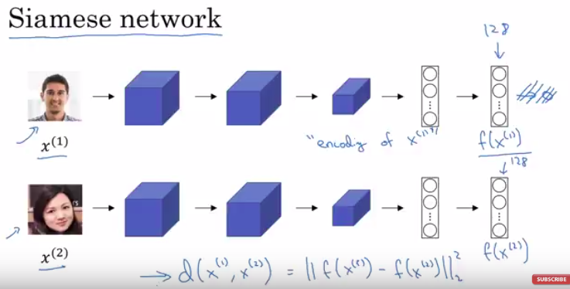

we are not interested in the probabilities of number of employees or the classes
we are intered in the vector produced just before the final probability 128 feature vector

these images are passed through the CNN

and then we make a similarity function which is the distance between the known and unknown images.

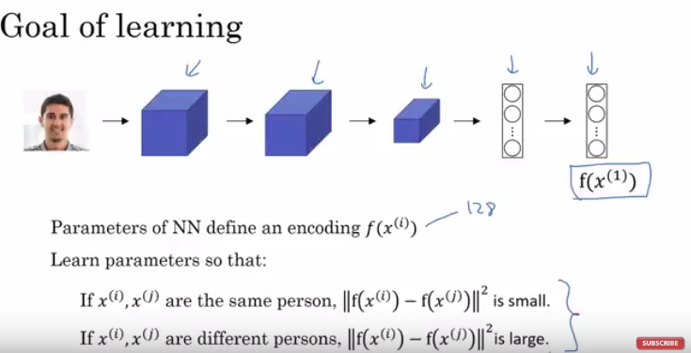

We adjust the weights through backpropogation

HOW??

satisfying the given condition in every iteration of CNN

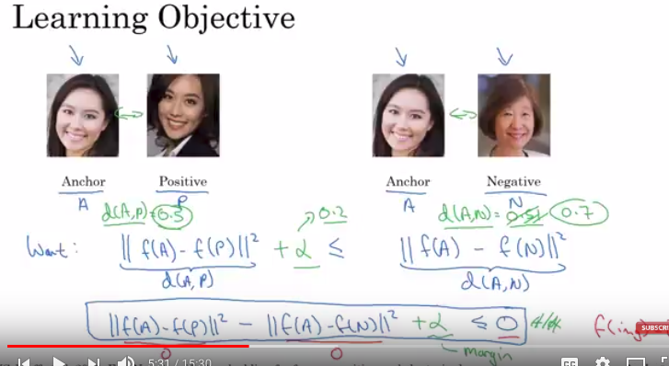

we don’t want both 128 encoding to be identical
so we add a hyper parameter alpha
which pushes or lowers the distance between the
pair of anchor-positive and achor-negative so that the above equation can be satisfied.

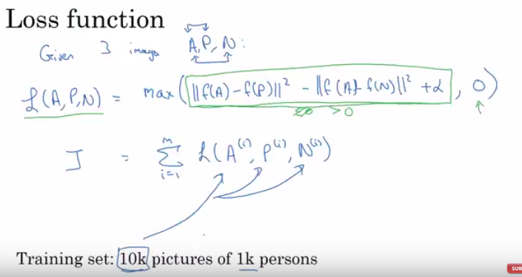

To minimize the loss we use the gradient decent to tune the hyper parameters.

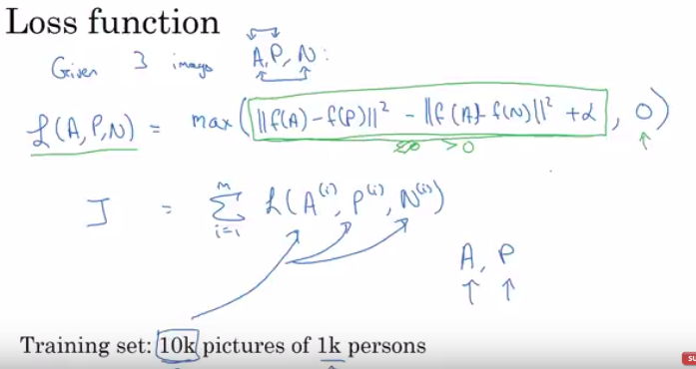
For training we need more than one picture of a person, but for testing we only need one picture of person.

In CNN we change tee feature vector or filter values in every iteration

and in normal neural network we imporve the y=mx+c
in this m and c in every iteration using gradient decent.
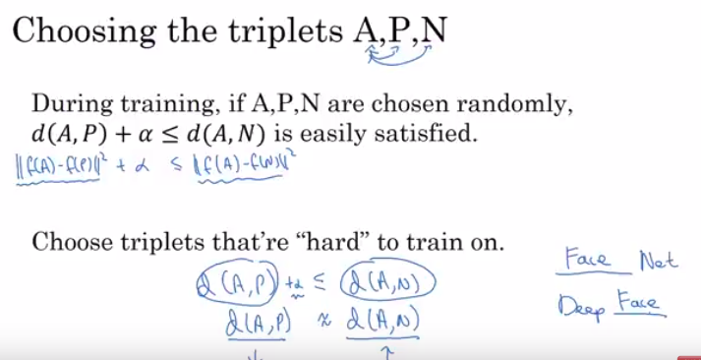

So finally after traning by minimizing the triplet loss
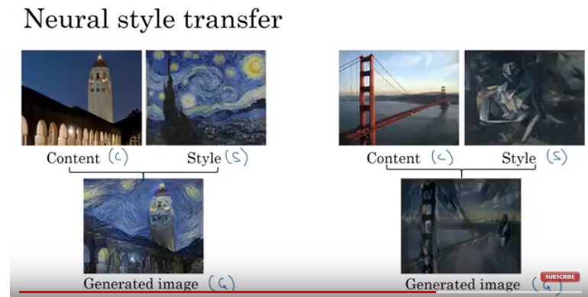
we find a model to give proper encoding.

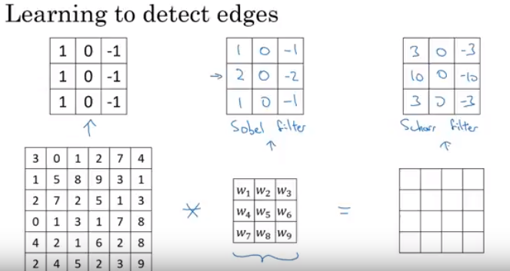
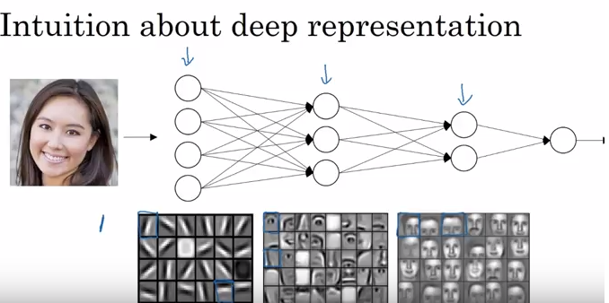
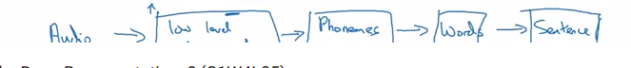
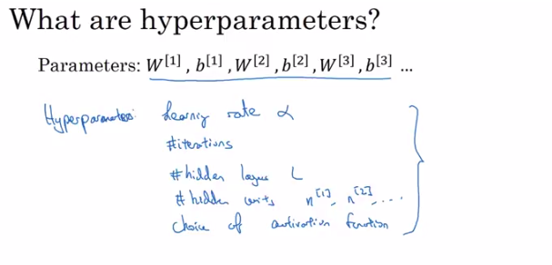
Initial layes do the small detections like edges and later do the more complex features like eye or nose

